ACTIVITY 3

TOPIC 3

Tim A James

GCU | CST-236 Database App. Prog. II  3/13/21

# GITHUB REPO URL

<https://github.com/tjames222/CST-236>

# SCREENSHOT 1

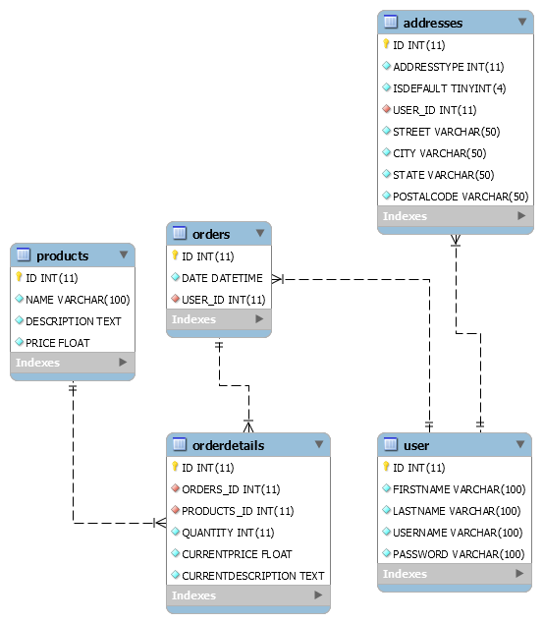ER Diagram from part 1 data base made with SQL workbench.

# SCREENSHOT 2

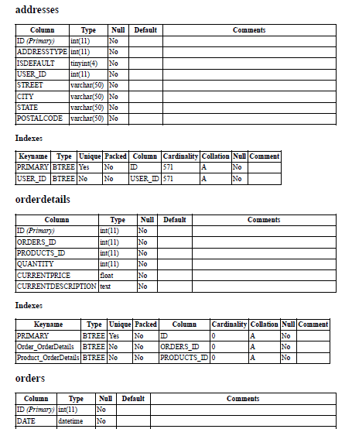Data dictionary created from Part 1 Database design

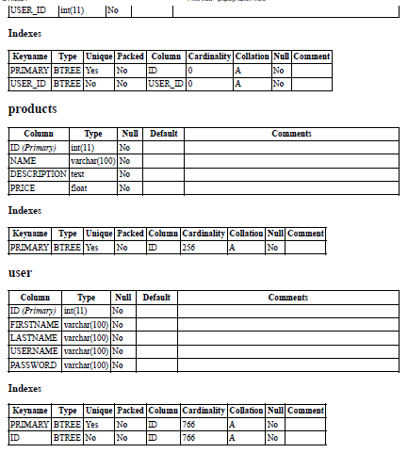

# SCREENSHOT 3

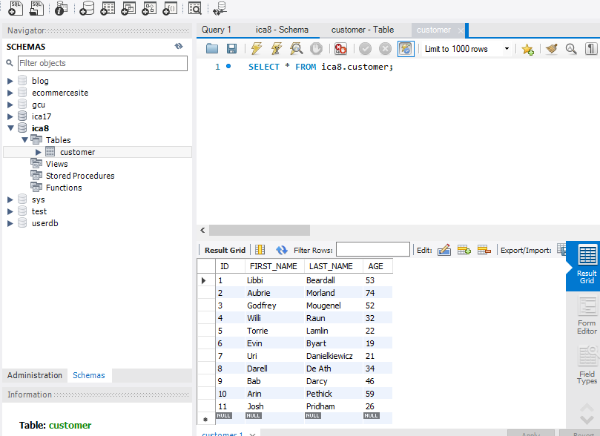Data imported from step6b mysql data imports

# SCREENSHOT 4

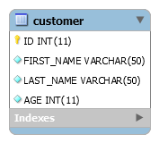ER Diagram exported from step 6c mysql imports

# SCREENSHOT 5

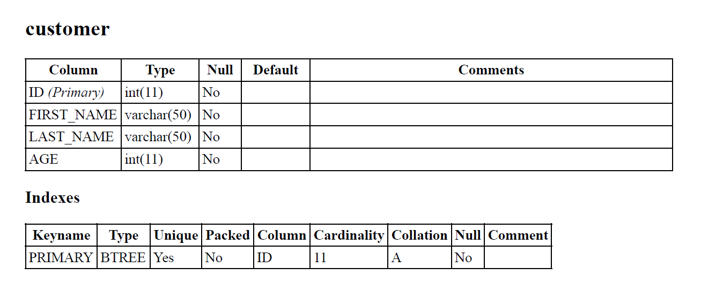Data dictionary from step 6d ica8 table

# SCREENSHOT 6

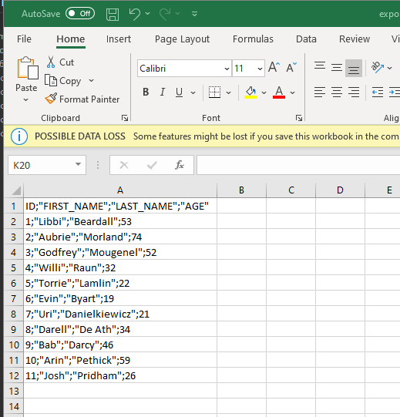Data exported from step 7g

# SCREENSHOT 7

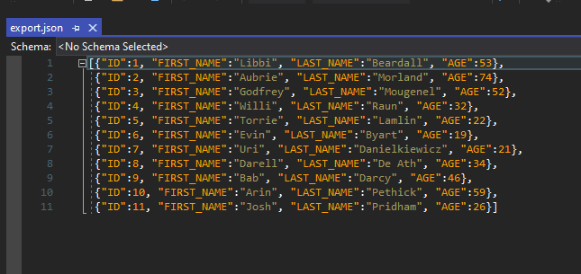Data exported from step 7i json format

# SCREENSHOT 8

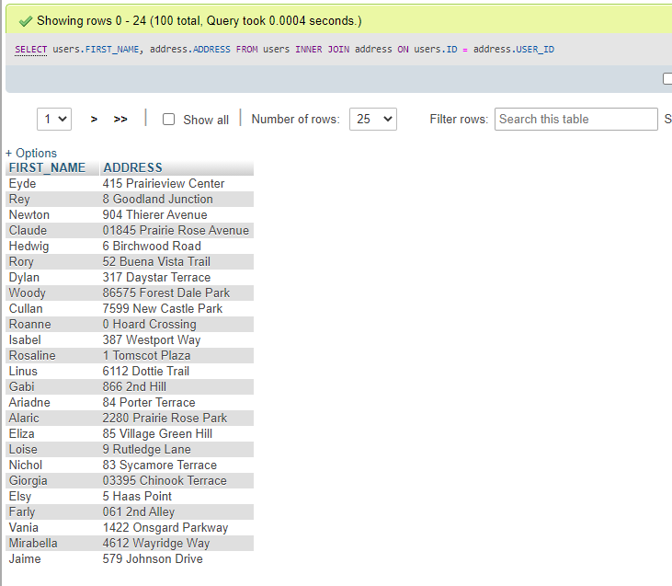Screenshot of SQL queries from step 2a showing an inner join.

# SCREENSHOT 9

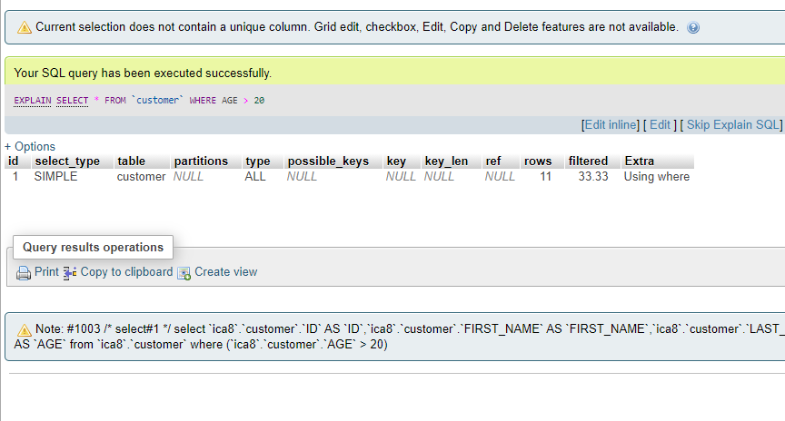Results grid from explain select query without index.

# Screenshot 10

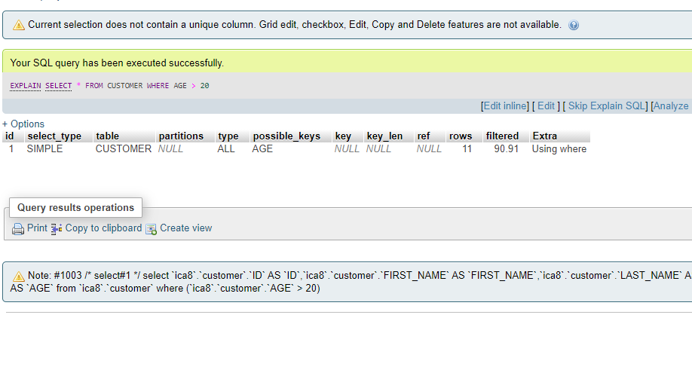Results grid from explain select with index

# SCREENSHOT 11

Showing index from query